**LM Assignment 1**

**Q-1.Java JDK/JRE installation :**

**-->** Following Steps followed:

1. Go to the Oracle website and download the latest JDK (Java Development Kit)

1. Run the downloaded JDK installer

4. Set up the JAVA_HOME environment variable

6. Test your installation by running the "java" command from the command line

1. **Go to the Oracle website and download the latest JDK (Java Development Kit)**

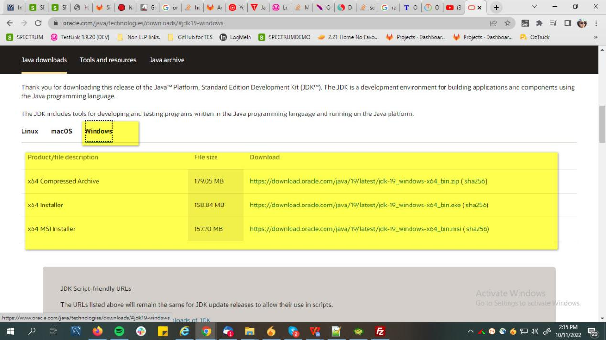

1. Run the downloaded JDK installer

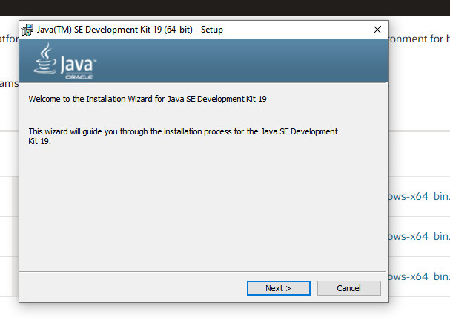

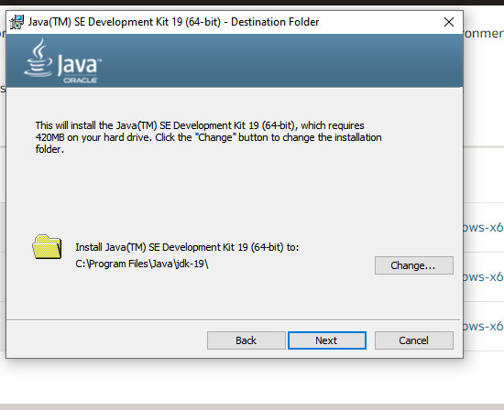

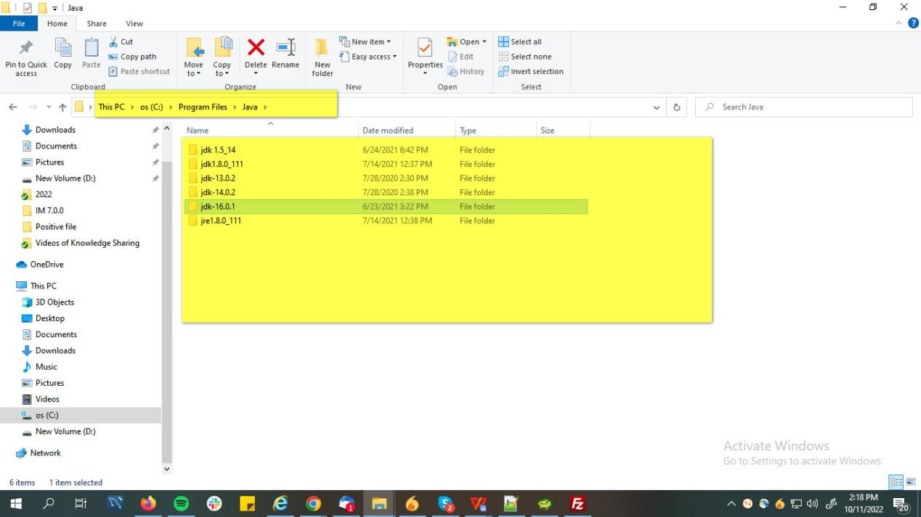

**In CMD :**

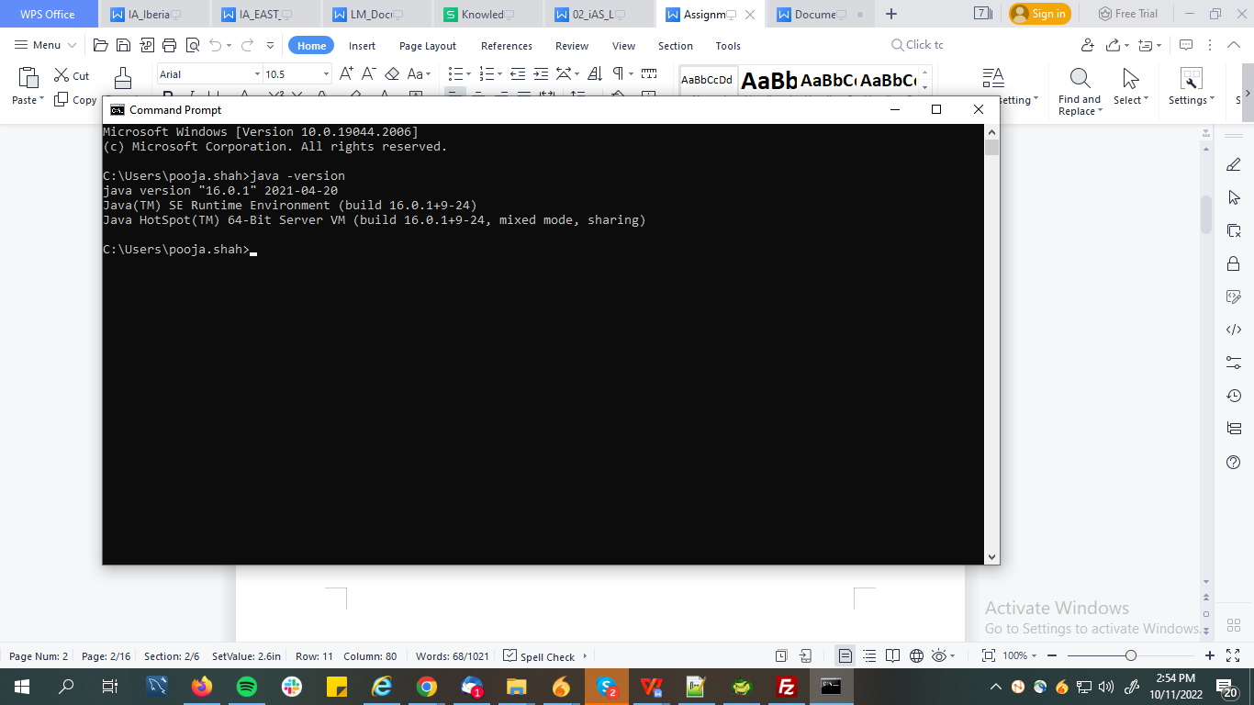

**Q-2 . Set Environment Variable :**

**-->** 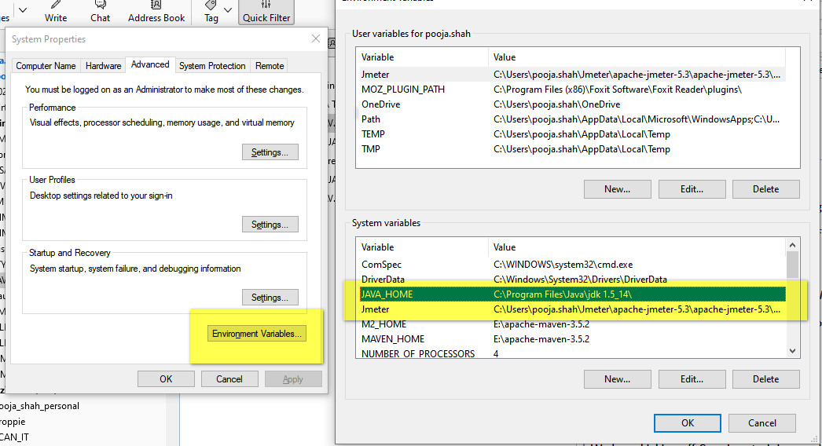

1. **3. Create a program in Notepad for "Hello World", compile & run it.**

**--> CODE :**

**public class HelloWorld**

**{**

**public static void main(String []args)**

**{**

**System.out.println("Hello My World!! My Name Is POOJA !!");**

**}**

**}**

